**Poslovna zona a.d. Banja Luka – Business Zone**

This zone is located within the former Incel factory and occupies the surface of 80 ha. In the table below, the main characteristics and available spaces of this zone are shown. There is an offer of Greenfield locations, as well as empty objects intended for production or storage.

|  |  |  |
| --- | --- | --- |
| **No** | **Information** | |
| 1 | Was the Decision on establishment brought? Date of the Decision | Yes  071-0-Reg.-09-001226, September 14th 2009 |
| 2 | Name of the zone | „Poslovna zona“ a.d. Banja Luka |
| 3 | Type of investment (greenfield, brownfield) | Greenfield and brownfield |
| 4 | Land area | 80 ha |
| 5 | Owner | Poslovna zona a.d. Banja Luka |
| 6 | Location description according to the transport corridors | * Vicinity of the city centre (2 km), secured by a straight line road, which became very important when a bridge across Vrbas near City Heating Plant was built * Connection through industrial track with a rail station in Vrbanja, stated approximately 400 m of the cargo entrance. * Direct connection to the regional road Banja Luka, Kotor Varoš, Teslić, Doboj * Existing lines of the public city transport and a bus stop with furnished platform near the main entrance of the Business Zone * Existing passengers rail station near the main entrance of the Business zone * Direct access to the Eastern transit allows easy and fast connection to the bus and railway stations Banja Luka and exit to the highway Banja Luka-Gradiška. |
| 7 | Number and area of the available land for investments | 11 ha is owned and built by “Poslovna zona” a.d. Banja Luka  The rest of the area is available for investors (120 parcels 20-41 x 40-48 m²) – approximately 30 ha  Many existing objects are intended to be demolished. |
| 8 | Business opportunity: purchase of land, renting of land in the zone | Rent (for at least 5 years, maximum 25 years)  Purchase |
| 9 | Price of the purchase or rent | Land is rented indefinitely  Purchase – price: 120 KM/m² (2015) |
| 10 | Infrastructure (electrical energy, water, sewerage system, telecommunications, access roads) | Industrial tracks, sewerage system, water supply, electrical energy, telecommunications, access roads. |
| 11 | Priority sector for investment | Possible negotiation with the investor |
| 12 | Procedures and conditions of entering the zone (specify the name of the document that determines them) | * Area of the parcel is adapted to the needs of the investors * Bidding, calls for objects renting * Potential investors |
| 13 | Existing enterprises in the zone | SHP Celex, , BC Metal, Beorol, Drvodom, Elgrad, GTS; Interlignum, Lanaco, Orfej, Windoorplast etc. |
| 14 | Documentation necessary for investing, the issuer (spatial and regulation plan, permissions, consents) | * Existing regulatory plan “Industrial complex Medeno polje” * Location conditions, building permit, use permit and other permits according to the type of the investment |
| 15 | Other information | New roads and industrial and business objects are planned to be built on this location  Existing parcels |
| 16 | Contact | Poslovna zona a.d. Banja Luka  051/450-164 |

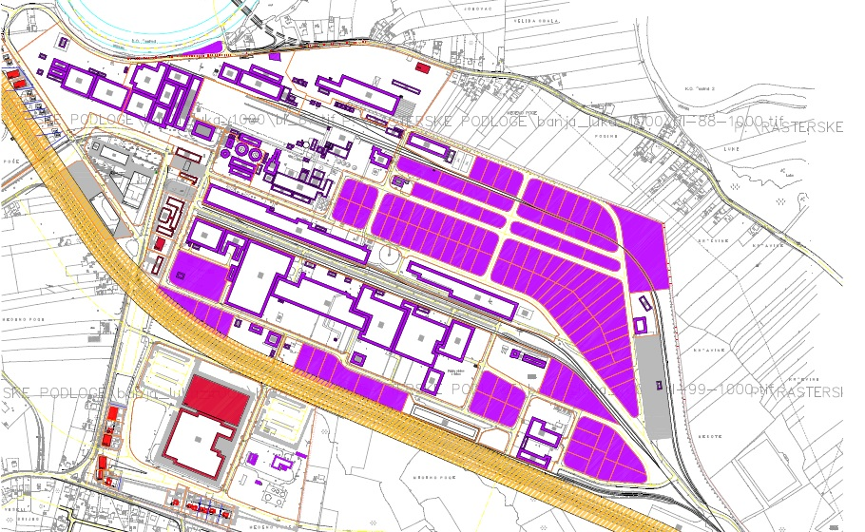

**Parcels intended for rent/sale**

**Objects for rent**

|  |  |  |
| --- | --- | --- |
| **No** | **Object** | **Information** |
| 1 | Name of the object | **Business space and storage** |
| 2 | Type of investment (brownfield, joint venture) | Brownfield |
| 3 | Area and the description of the object | 230 m² |
| 4 | Owner | Poslovna zona a.d. Banja Luka |
| 5 | Description of the object location according to the transportation corridors | * Vicinity of the city centre (2 km), secured by a straight line road, which became very important when a bridge across Vrbas near City Heating Plant was built * Connection through industrial track with a rail station in Vrbanja, stated approximately 400 m of the cargo entrance. * Direct connection to the regional road Banja Luka, Kotor Varoš, Teslić, Doboj * Existing lines of the public city transport and a bus stop with furnished platform near the main entrance of the Business Zone * Existing passengers rail station near the main entrance of the Business zone * Direct access to the Eastern transit allows easy and fast connection to the bus and railway stations Banja Luka and exit to the highway Banja Luka-Gradiška. |
| 6 | Business opportunity: purchase of land, renting of land in the zone | Renting |
| 7 | Price of the purchase or rent | Object renting  4-5 KM/m² (possibility of negotiation with the investor and according to the area of the object – the larger object, the price is lower) |
| 8 | Infrastructure (electrical energy, water, sewerage system, telecommunications, access roads) | Access asphalt road, water system, sewerage system, electrical energy, lightning rod, hydrant network, telephone connection |
| 9 | Object purpose | **Business space and storage** |
| 10 | Documentation necessary for investing, the issuer (spatial and regulation plan, permissions, consents) | * Existing regulation plan Privredni kompleks Medeno polje – Industrial complex Medeno Polje * Location conditions, building permit, use permit |
| 11 | Other information | Total floors: ground level + 1 floor (130 + 100 m²) |
| 12 | Contact | Poslovna zona a.d. Banja Luka  051 450 104 |



|  |  |  |
| --- | --- | --- |
| **No** | **Object** | **Information** |
| 1 | Name of the object | **Business and storage space** |
| 2 | Type of investment (brownfield, joint venture) | Brownfield |
| 3 | Area and description of the object | 3 950 m² |
| 4 | Owner | Poslovna zona a.d. Banja Luka |
| 5 | Description of the location according to the transport corridors | * Vicinity of the city centre (2 km), secured by a straight line road, which became very important when a bridge across Vrbas near City Heating Plant was built * Connection through industrial track with a rail station in Vrbanja, stated approximately 400 m of the cargo entrance. * Direct connection to the regional road Banja Luka, Kotor Varoš, Teslić, Doboj * Existing lines of the public city transport and a bus stop with furnished platform near the main entrance of the Business Zone * Existing passengers rail station near the main entrance of the Business zone * Direct access to the Eastern transit allows easy and fast connection to the bus and railway stations Banja Luka and exit to the highway Banja Luka-Gradiška. |
| 6 | Business opportunity: purchase of land, renting of land in the zone | Rent |
| 7 | Price of the purchase or rent | Object renting  4-5 KM/m² (possibility of negotiation with the investor and according to the area of the object – the larger object, the price is lower) |
| 8 | Infrastructure (electrical energy, water, sewerage system, telecommunications, access roads) | Access asphalt road, water system, sewerage system, electrical energy, lightning rod, hydrant network, telephone connection |
| 9 | Purpose of the object | Business and storage space |
| 10 | Documentation necessary for investing, the issuer (spatial and regulation plan, permissions, consents) | * Existing regulation plan Privredni kompleks Medeno polje – Industrial complex Medeno Polje * Location conditions, building permit, use permit |
| 11 | Other information | Total floors: ground level and two floors (3 190+320+440 m²) |
| 12 | Contact | Poslovna zona Banja Luka  051 450 104 |

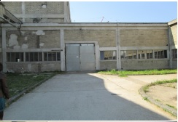

|  |  |  |
| --- | --- | --- |
| **No** | **Object** | **Information** |
| 1 | Name of the object | **Business and storage space** |
| 2 | Type of investment (brownfield, joint venture) | Brownfield |
| 3 | Area and the description of the object | 70 m² |
| 4 | Owner | Poslovna zona a.d. Banja Luka |
| 5 | Description of the location according to the transport corridors | * Vicinity of the city centre (2 km), secured by a straight line road, which became very important when a bridge across Vrbas near City Heating Plant was built * Connection through industrial track with a rail station in Vrbanja, stated approximately 400 m of the cargo entrance. * Direct connection to the regional road Banja Luka, Kotor Varoš, Teslić, Doboj * Existing lines of the public city transport and a bus stop with furnished platform near the main entrance of the Business Zone * Existing passengers rail station near the main entrance of the Business zone * Direct access to the Eastern transit allows easy and fast connection to the bus and railway stations Banja Luka and exit to the highway Banja Luka-Gradiška. |
| 6 | Business opportunity: purchase of land, renting of land in the zone | Rent |
| 7 | Price of the purchase or rent | Object renting  4-5 KM/m² (possibility of negotiation with the investor and according to the area of the object – the larger object, the price is lower) |
| 8 | Infrastructure (electrical energy, water, sewerage system, telecommunications, access roads) | Electrical energy, lightning rod, hydrant network |
| 9 | Purpose of the object | Business and storage space |
| 10 | Documentation necessary for investing, the issuer (spatial and regulation plan, permissions, consents) | * Existing regulation plan Privredni kompleks Medeno polje – Industrial complex Medeno Polje * Location conditions, building permit, use permit |
| 11 | Other information |  |
| 12 | Contact | Poslovna zona Banja Luka  051 450 104 |

