Business zone „Jelšingrad“
City of Banja Luka granted the land in Zaluzani (former military barracks) to the Ministry of the Inner Affairs of the Republic of Srpska. Total area of the land is 31 179 m². By the Decision of the Republic of Srpska Government, on the March 16th 2017, the City of Banja Luka was asigned 28 ha of the former factory Jelšingrad land, which will be used for the establishment of a new business zone. In the table below, basic data about the zone are shown.

No | Land | Information
1 | Name of the location | Land next to the company “Novi Jelšingrad”
2 | Agricultural or building land | Building
3 | Type of investment (greenfield, joint investment) | Greenfield + brownfield
4 | Land area | Surface: 28 194 m²  1684/3 K.O. Budžak
5 | Owner | City of Banja Luka
6 | Description of the location according to the transport corridors | Ilije Garašanina Street connects the zone to the highway Banja Luka - Gradiška
7 | Business possibilities: purchase, renting, concession | Purchase
8 | Price of purchase or renting | Price of the building land  3rd zone - 106,9 KM/m² (subject to change, see the footnote)
9 | Infrastructure (electrical energy, water, sewerage system, lighting, telecommunications, access roads) | Equipped
10 | Land purpose | Economic activities – business object
11 | Documentation necessary for investing, the issuer (spatial and regulation plan, permissions, consents) | Change of the Regulation Plan “Jelšingrad” RO Factory of the tool machines – revised plan  Necessary documents: location conditions, construction permit, and other necessary permits
12 | Other information | There are two existing industrial objects on this location – area 5 m² and 428 m²
13 | Contact | Department of Local Economic Development and Strategic Planning – City of Banja Luka  051/244-427

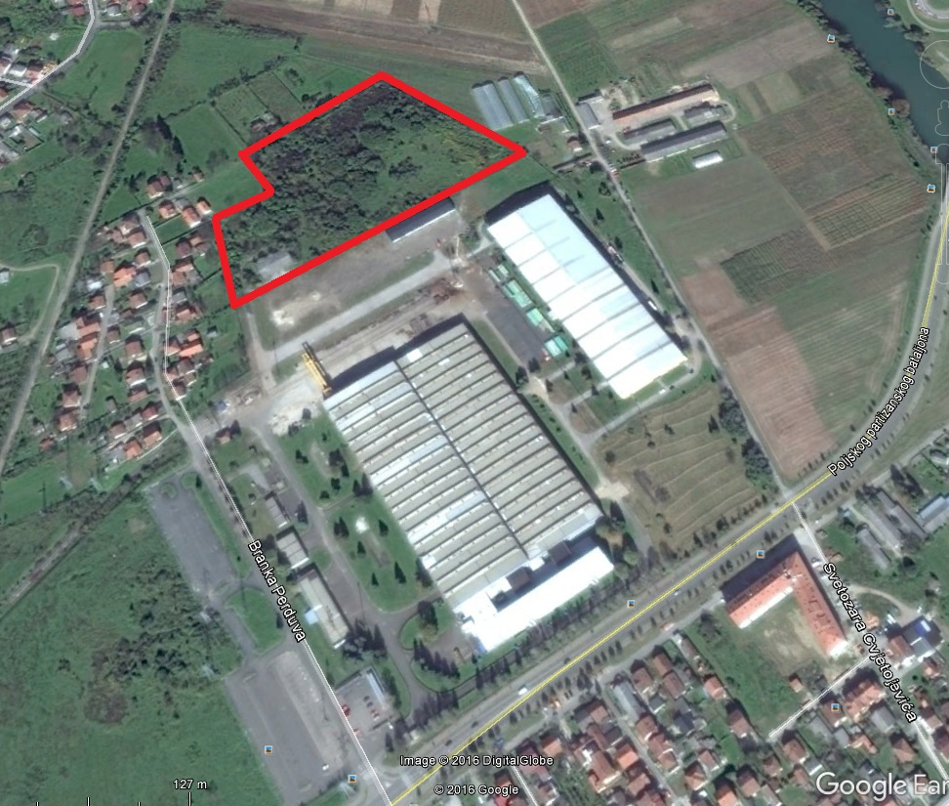
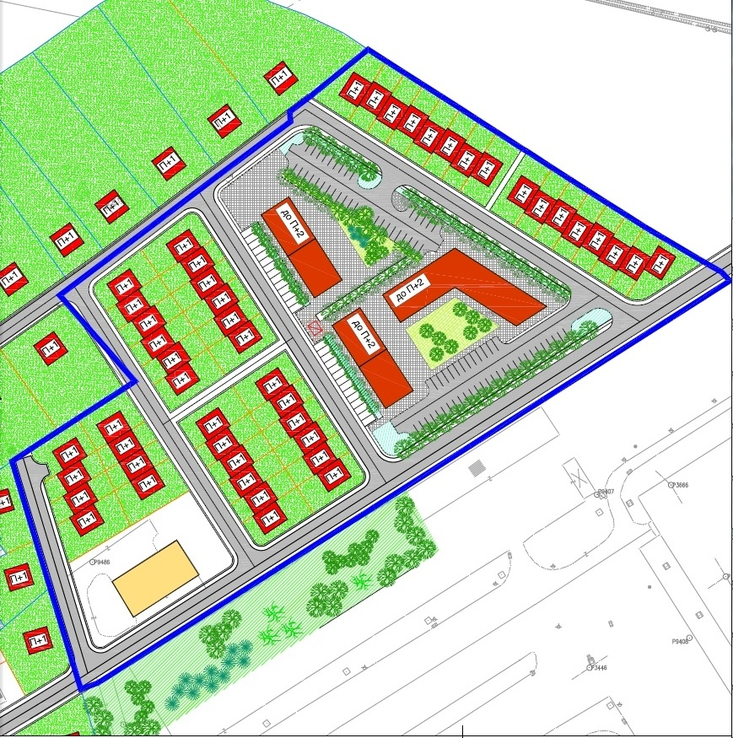

A document Rješenje o vrijednostima koeficijenata za korekciju procijenjene tržišne vrijednosti nepokretnosti za 2016. godinu can be found on the following website and there is a detailed proccess of the prices calculation https://www.poreskaupravars.org/SiteCir/UpisFiskalniRegistarNepokretnostiInfo.aspx

